EXERCISE-2

**Boundary conditions for Q_Flood**

11/06/1994 12:00 AM to 11/08/1994 01:00 AM

**Task 1: Set-up of a basic model for normal flow conditions**

Creating a simplified Mike11 river model for steady conditions based on the provided data set of Var river of nearly 5 days with steady flow conditions.

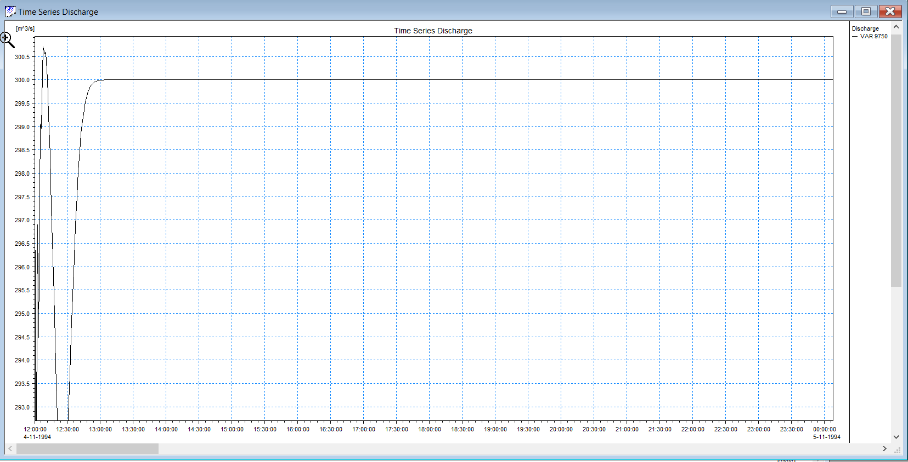

**Figure 1**: Time series discharge for normal flow

## Task 2: Set-up of a basic unsteady model for the flood event 1994

## Mike11 river model with hydrograph as upstream flow related to the 1994 flood event.

## 

**Figure 2&3:** Time series flood graph(above) and Longitudinal profile(below)

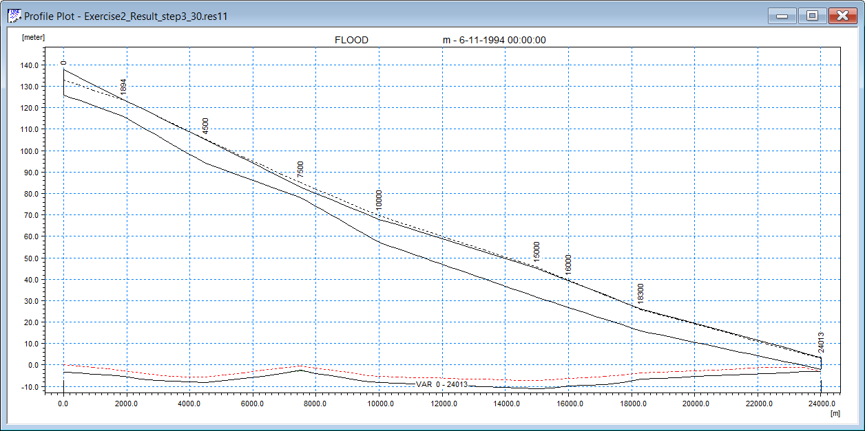

## Task 3: Parameter study - bed resistance

So, we have chosen 4 manning values for the sensitivity analysis: n = 15; n = 30; n = 45; n = 60; n = 75

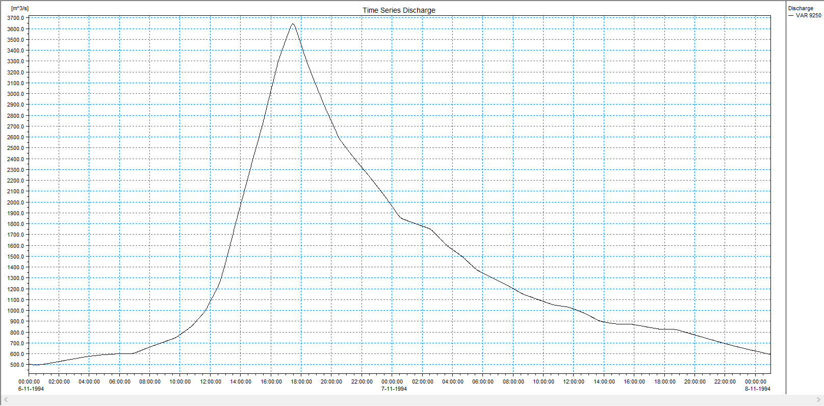

**Figure 4**: Time series graph for manning at 15

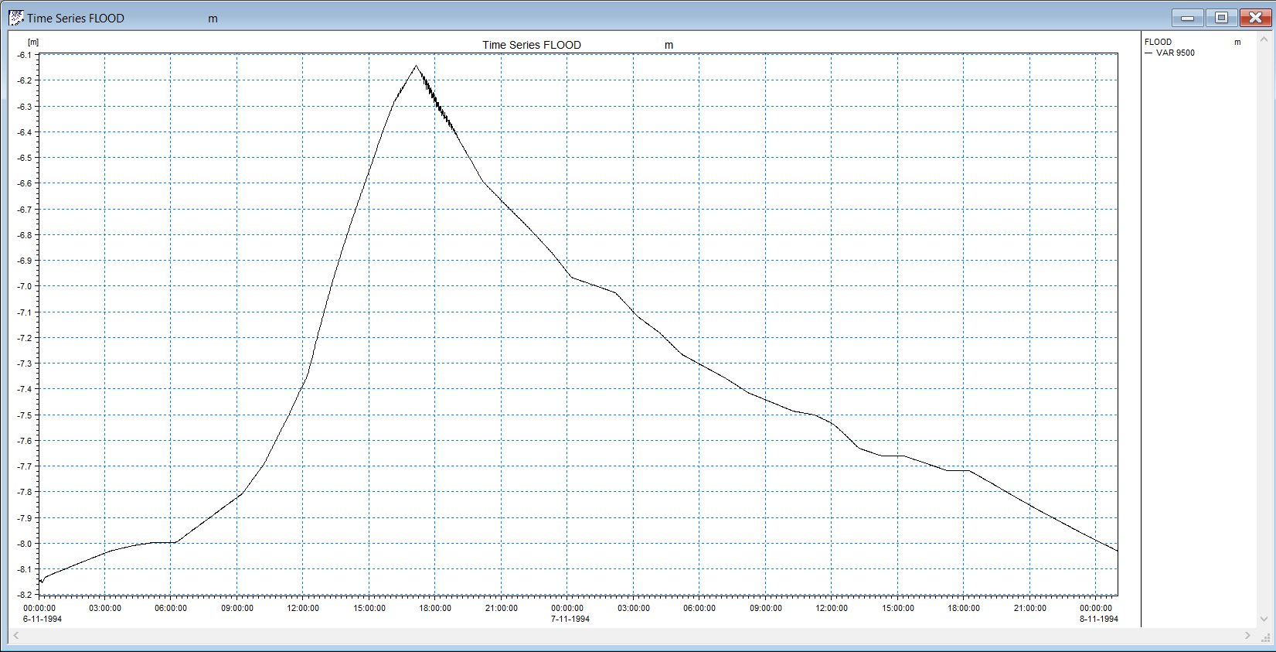

**Figure 5**: Time series graph for manning at 75

**Task 4: Weir impact**

The cross section was changed from 15000-16000 to 15500-16000. This cross-section was chosen so that the simulation could run.

The is because the weir was introduced at a cross-section of 15200.

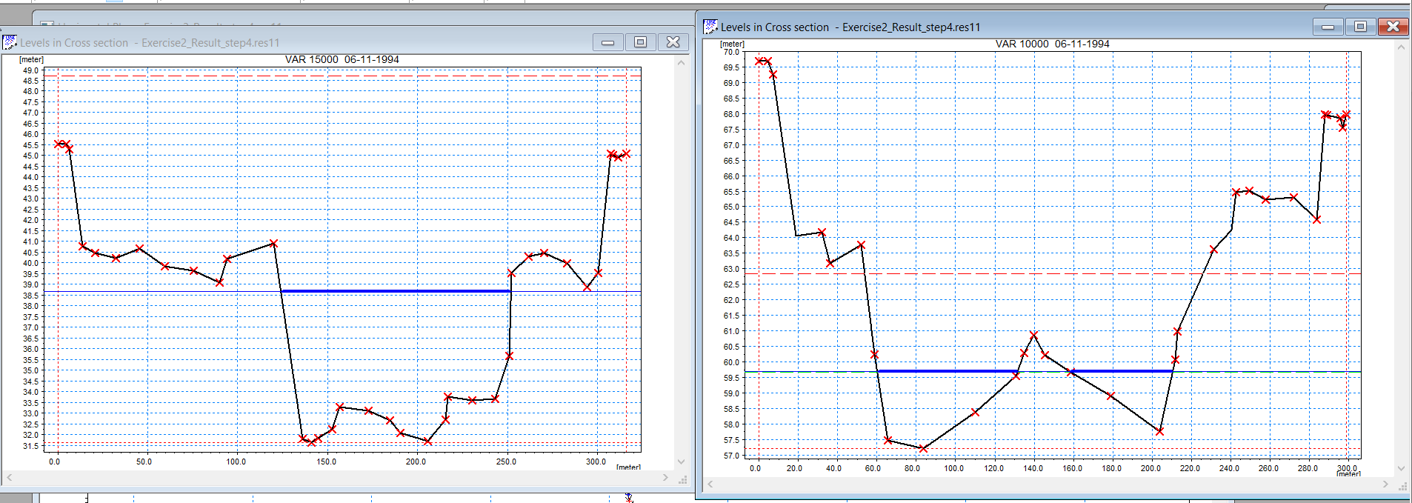

**Figure 6**: Comparing the different Cross sections

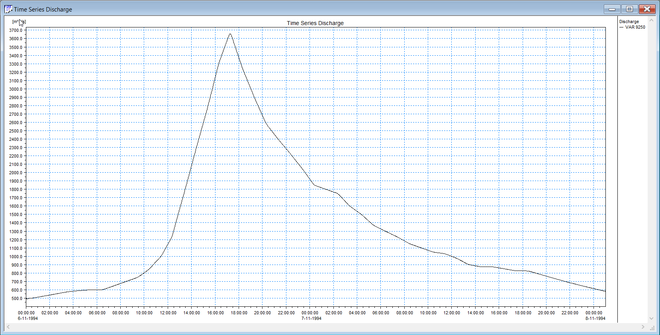

**Figure 7**: Timeseries discharge with weir

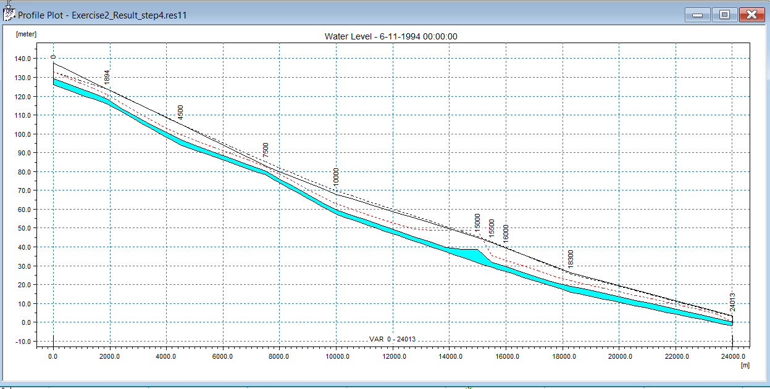

**Figure 8**: Longitudinal profile of water level

m3/s

